

Transition Guide

v2024-06-16

# Title Gradient 6What is QuestGuard?

QuestGuard is a gamified tactical tabletop roleplaying game for the younger generation, who are more used to video games and board games, and wants a fast, rules-light and combat-focused alternative to the mainstream and older systems.

While playing QuestGuard, you will find more “gamified” elements, both for the players and for the Quest Master. There is emphasis on build variety, combos, rules to help Quest Masters have an easier time, and depth through interactions, not complexity.

We created QuestGuard out of love for tabletop roleplaying, to fit our needs and, most importantly, to fit with how the current generation *actually* plays combat RPG’s.

If you’ve played Dungeons & Dragons or Pathfinder, you will find QuestGuard very easy to pick up!

## Is this a D&D mod or spin-off?

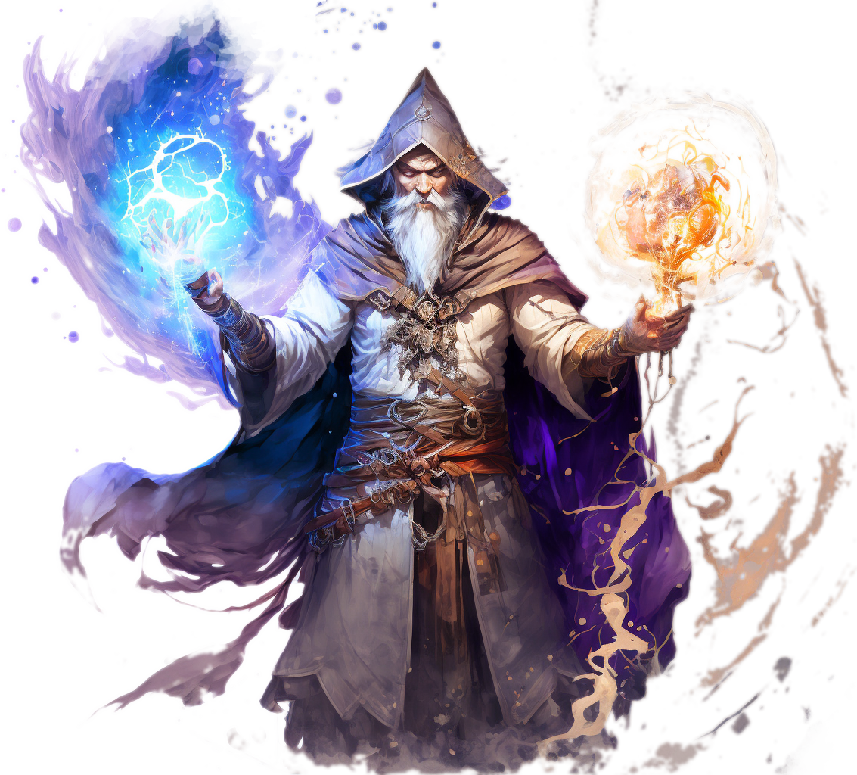No, QuestGuard is its own game, completely separate from D&D.

What to expect?

QuestGuard is systems-light - there are hardly any tables, no *concentration* rule, no spell components or spell slot levels, no roll to hit or opportunity attacks, no *saves* (checks) in combat (crowd control/status effect is direct and fair).

There are long or short rests, as the Quest Master has better control over the pacing through the **Adventure** and enemy **Worthiness** system.

Character abilities are *gamified* for gameplay rather than realism, to be able to do things such as creating gold or magic items out of thin air or *farming* enemies. Characters can *respec* between Adventures, all monsters are tactical and change how you must approach combat, and this is the tip of the iceberg!

## How to get into it?

You’re already in it!

Our website <https://questguardrpg.com> features a “Play With Us!” button. Once clicked, it will redirect you to our Discord group, where we regularly host campaigns and one-shot adventures for new and old players alike!

Feel free to say hi and show your character!

# Title Gradient 6Why QuestGuard?

There are plenty of reasons to choose and play QuestGuard!

## It’s “gamey” and it flows

Everything in QuestGuard is intended to have a good flow in combat, be simple and allow for awesome Ability combinations.

The complexity and skill expression does not come from number crunching, but rather from how you choose to combo your character pieces together.

All math is as simple as possible, your character build flows and all game elements fit in such a way that they don’t hinder one-another. **It’s clean**.

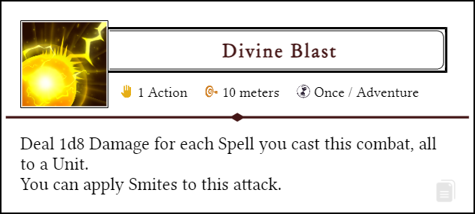

Figure out your own combos and unleash them upon your foes!

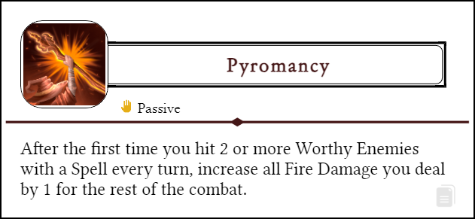

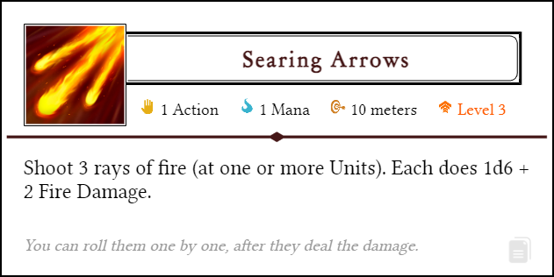

Every class and build path is different and breaks the rules of the game!

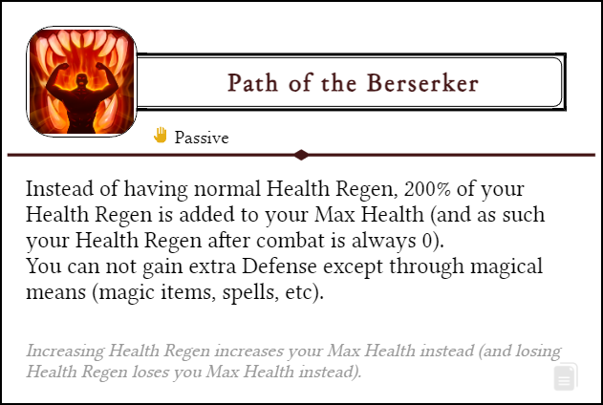

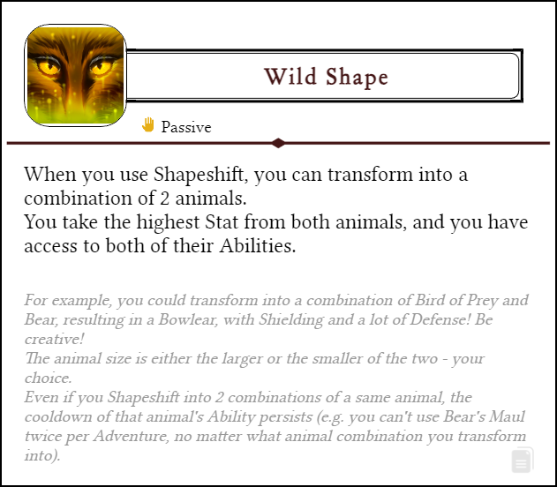

There are **hundreds** of such Abilities in the game, and the possibilities are in the **millions**!

## Being a Quest Master is easy

QuestGuard is made to be cool for players, and easy for the Quest Master (the game master). Through rules such as the **Adventure**, **Worthiness**, **Skills**, etc, you will find running Quest Guard both enjoyable and easy to manage.

## Always online

All the resources are always online. As such, there are frequent patches, balance improvements, content updates and much, much more!

# Title Gradient 6The Dice

QuestGuard is a **d12** system. Whenever you roll a Check, you roll a 12-sided die and add any modifiers to it.

A natural 12 is a Critical Success and counts as 15.

Getting 0 or less on a Check would constitute a Critical Failure (through negative modifiers).

## Which dice are used

In QuestGuard, we use the standard polyhedral dice - **d4**, **d6**, **d8**, **d10**, **d12** and **d20** (although the **d20** is rarely used).

## Combat dice

In combat, there is no rolling to hit. Whenever you attack, you roll for Damage directly - most of the time, what you see is what you get. If you rolled a total of 14 on 3d6, you deal 14 Damage.

By default, there are no critical strikes, but some weapons and Abilities can trigger bonus effects based on the rolls. If it can, it is neatly mentioned in its text box.

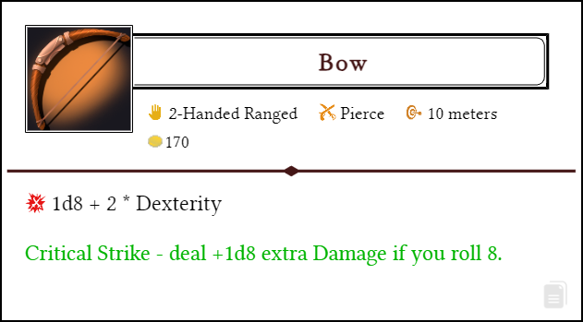

Most of the time, you will deal and take Damage. Be prepared!

# Title Gradient 6Characters

## Character sheet

Like in most RPG’s, a Player Character needs a character sheet.

You can find it on the website at <https://questguardrpg.com> under Downloads.

The PDF version is editable. Make sure you save it!

## What makes a Character

A Player Character is made up of a Race plus a Class. Each of these has a ton of customization options.

Each Race has a Racial Ability you can choose. Each Class has a Specialization, and then, every level, gets a choice of one out of 2 or 3 Talents to pick, which are powerful Abilities that shape how your Character plays and fights.

Don’t be afraid to try strange combinations! Player Characters can freely “respec”, changing all Talent choices and learned Abilities.

## Progression

There are 10 Levels Players can progress through with their Characters.

Levels are packed with interesting options. Every Level unlocks new Abilities, new pets or choices to make, new Talents, and more!

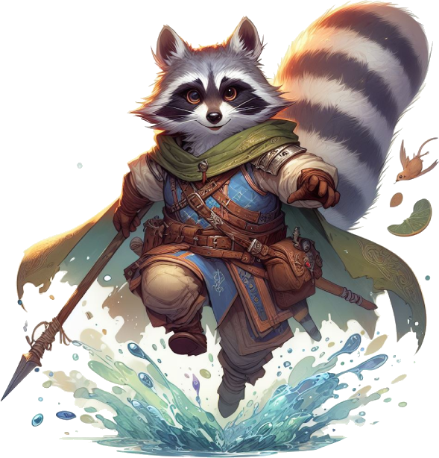The recommended way to Level-Up is through milestones or checkpoint set by the Quest Master. If using the Experience system, however, going from Level 1 to Level 10 should not take an eternity, either. QuestGuard intends campaigns to play out spanning a few months at most, but it’s all up to you and your group.

## Stats

There are 5 Main Stats in QuestGuard: **Might**, **Dexterity**, **Intelligence**, **Sense** and **Charisma**. The Stat is directly the “modifier”. In combat, each Stat affects an aspect of your character.

**Might** affects base **Health**.

**Dexterity** affects **Movement Speed**.

**Intelligence** usually affects the **availability of Abilities**, non-combat **Skills** and other roleplaying aspects.

**Sense** affects **Health Regen**.

**Charisma** affects **Initiative**.

All Stats also contribute to roleplay for Checks.

The calculations are be explained in Character Creation.

## Starting Stats

Everyone has the same stat numbers, ordered as you like: -1, 0, 1, 2, and 3. Put these numbers however you like in your 5 Stats.

Each way to distribute Stats is perfectly valid - there are builds and variations for any combination. QuestGuard is designed so that there is no objectively best way to do anything.

## Races & Stats

Races don’t increase or decrease Stats, but instead, each Race imposes some restrictions on Stats.



## Skills & Substats

There are no Skills listed on your Character Sheet.

When you want to do something, the Quest Master will simply call out for a “Might Check” or a “Sense Check”, for example.

However, each Character will have non-combat Skills they can **add themselves to the Check if appropriate**. If you have a Skill, you add your Level to the roll.

The Quest Master might call for a Sense Check, and, if you are Skilled in Sight, you can say “*I am Skilled in Hearing, can I add my Level to the roll?*”, to which the Quest Master might say yes or no, depending on the situation.

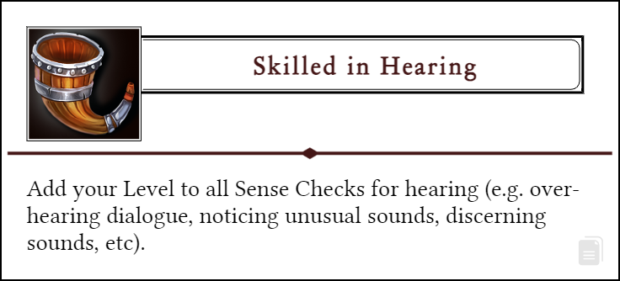

Let’s keep the Character Sheets clean!

If a non-combat Skill isn’t on the list, feel free to invent your own.

## Abilities

Almost **everything** you get in this game is an **Ability**. Skills, spells, attacks, moves, Feats, Talents, even weapons and armor!

An Ability is simply a rectangle with a clearly defined text, a little colorful icon and tags to help you identify its properties, such as the costs of using it, how often you can use it, the range, etc.

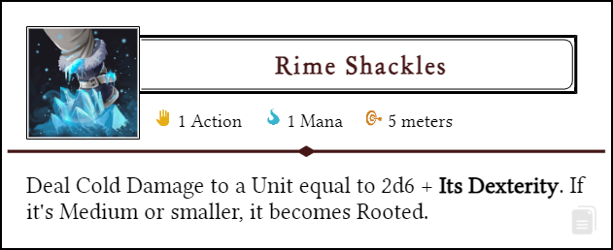

Most of the time, the only thing you need to use an Ability is your hands. No need for materials, a focus, spoken words, etc.

## Nifty website trick…

On the website, click on the little **document icon** on the bottom-right of an Ability to copy it to your clipboard. You can then paste it in a Word document, in a drawing app, etc.

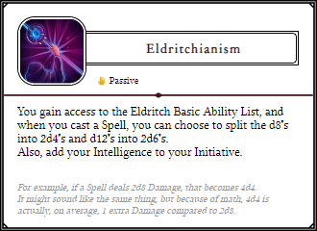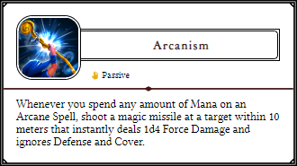

# Title Gradient 6Combat

Combat usually happens on a map, preferably on a grid, and distances are measured in meters.

The turn order for the players is determined by an Initiative roll (**1d12 + Initiative**). Monsters have fixed initiative and groups of monsters will take their turn simultaneously.

## Actions

Each character or monster in combat has **1 Action** and can **Move** **a number of meters up to their speed**.

Abilities that cost 0 Actions are free and can be done as many times as you like.

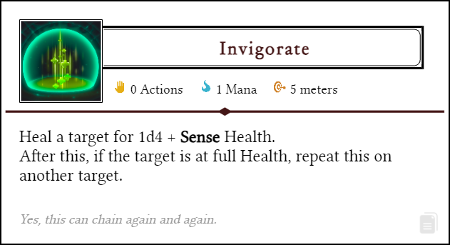

There is no “minor-action”, “bonus-action”, etc. However…

## Half-Actions

**1 Action** can be split into **2 Half-Actions**. Usually, when you do something with one hand, you use a Half-Action. When you use both hands at once, it’s 1 Action.

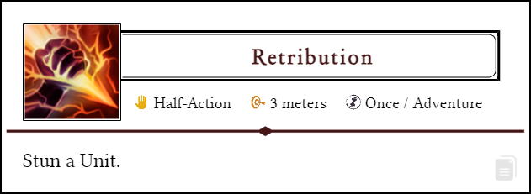

If you have a one-handed weapon like a dagger, **you can attack twice** with it, every turn, even if it’s the same hand.

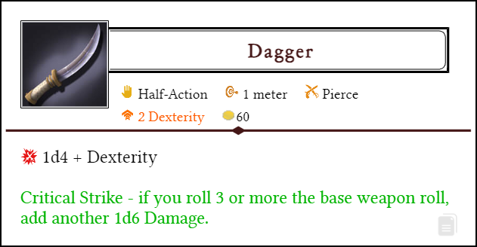

## Mana

The resource used to cast more powerful Abilities is called Mana. All Classes (except Hunters, Paladins and Rogues) use Mana.

You have a number of Mana Points you can use on Abilities.

If you have 5 Mana Points and an Ability requires 2 Mana, you spend 2 Mana and use the Ability. Then, you are left with 3 Mana.

Usually, Mana regenerates in the downtime between *Adventures*.

## Ability lists

Each Class can know a number of *Basic Abilities* from certain Ability Lists (yes, even non-casters). These are generic Abilities to complement your Class’s kit.

* *Bloodshed*
* *Warfare*
* *Elemental*
* *Arcane*
* *Mysticism*
* *Nature*
* 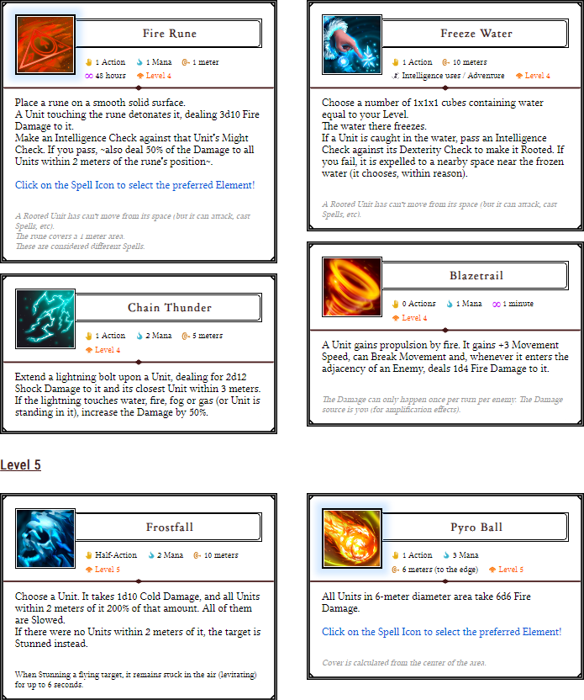*Divine*
* *Eldritch*

## Resting & regeneration

There are no *rests* like *short rests* or *long rests*.

You regenerate Health equal to your Health Regen after every Combat. Your Health Regen is defined by your Race.

You regenerate **all** resources (Health, Mana, etc) at the end of every *Adventure*.

## Adventures

An Adventure is a time period defined by the Quest Master. It could be a full dungeon, a play session, completing a quest, etc.

An Adventure that makes will have you use everything in your will to survive you will typically contain 3 medium-difficulty combat.

# Title Gradient 6Using the Website

All information on QuestGuard can be found for free online at [https://questguardrpg.com](https://questguardrpg.com.)

All Races, Classes, Abilities, etc are found under Databases.

## What’s next?

You should build a Character and show it to us on Discord! We’re happy to have you here and play with you and your new Character!

Click on this link to learn how to create a character: [https://questguardrpg.com/Download/Character_Creation_Guide_2024-10-19.pdf](https://questguardrpg.com/Download/Character_Creation_Guide_2024-06-16.pdf)

Or, if the link doesn’t open, go to the **Learn To Play** section of the website (https://questguardrpg.com), scroll down and click on the **Character Creation** guide. It will walk you through everything you need to create your first Character!

Feel free to also contact me (Dave) directly over there, I’ll gladly talk to you about the game, and answer any question you might have.

Enjoy adventuring!